## ED KIIRU

## R1:SP2: Story 2: Read input data

In Sprint 2, as a Developer I want to write ETL components that will read various types of 1003 mortgage application input data from various sources. So that I can insert that data into staging tables.

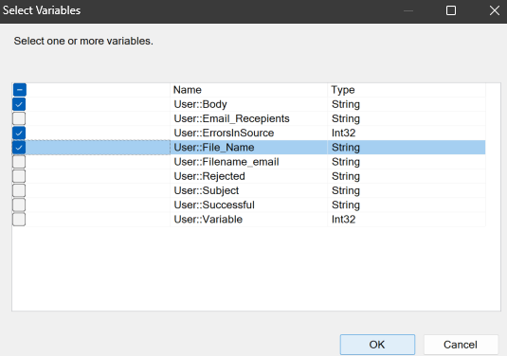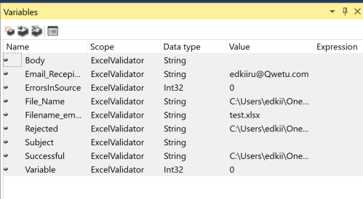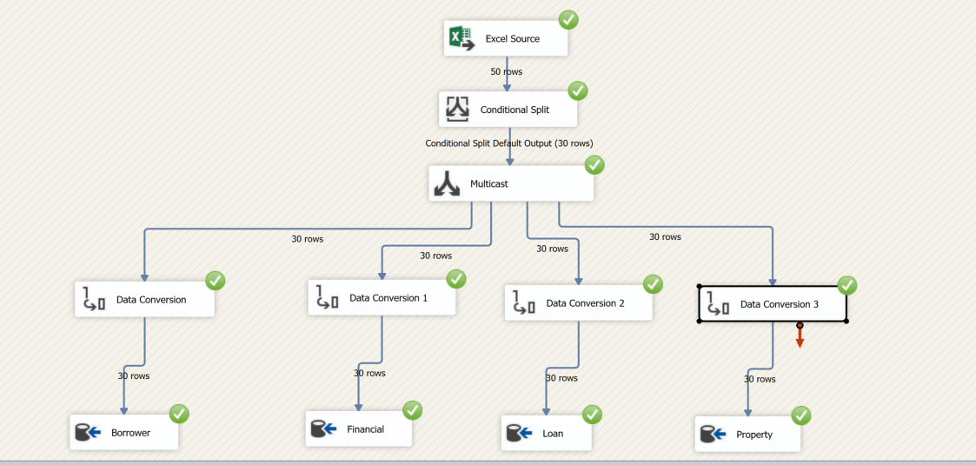

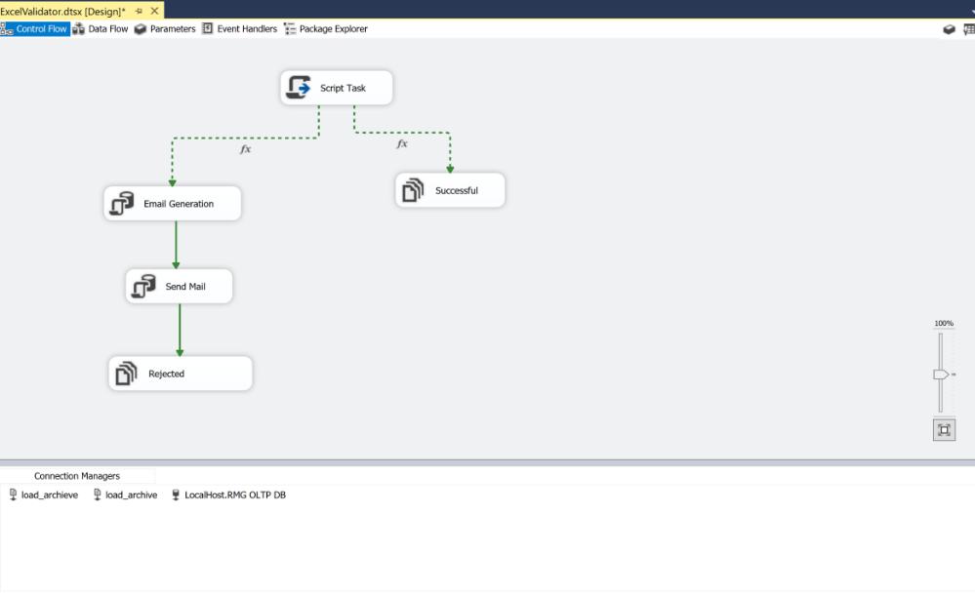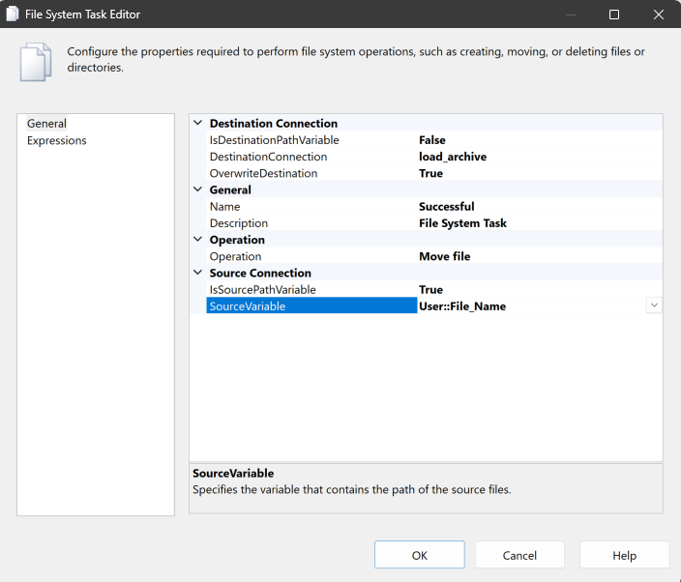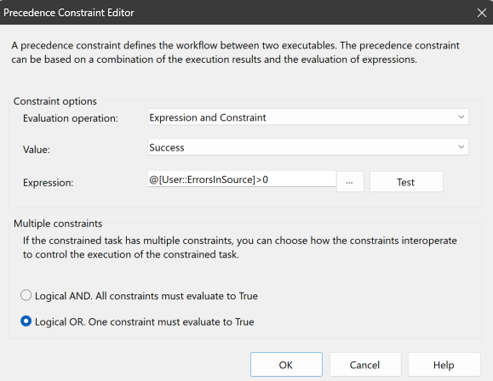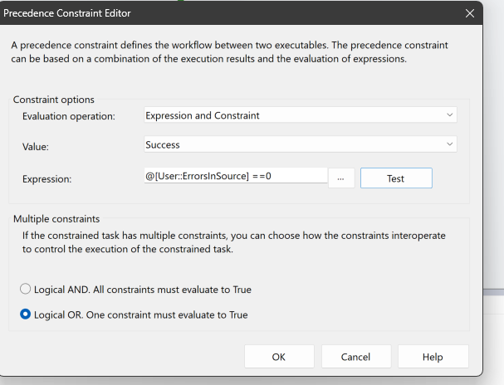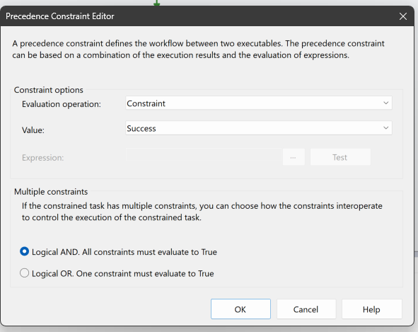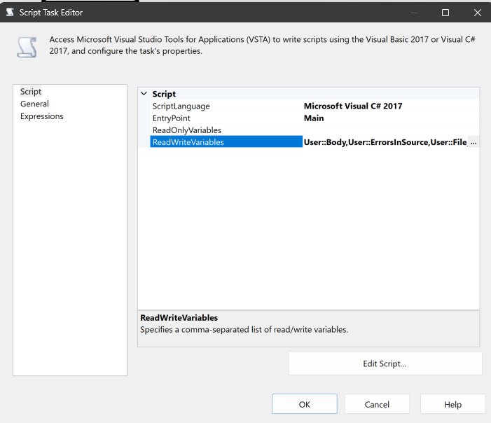

Scenario 2 : Loading XML

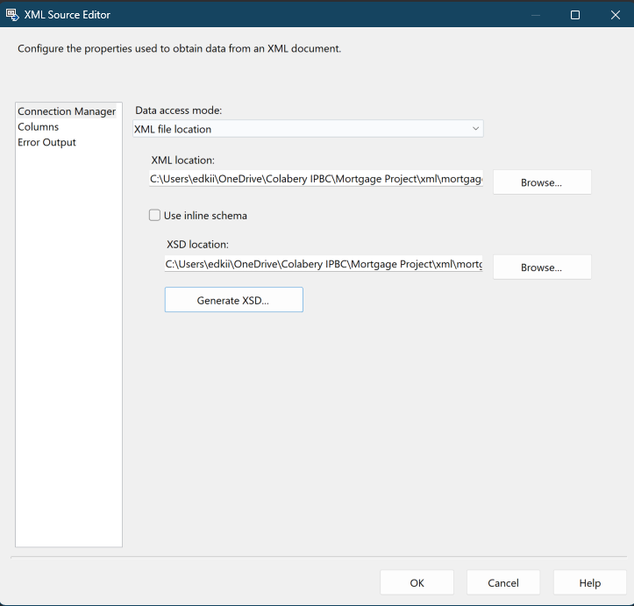

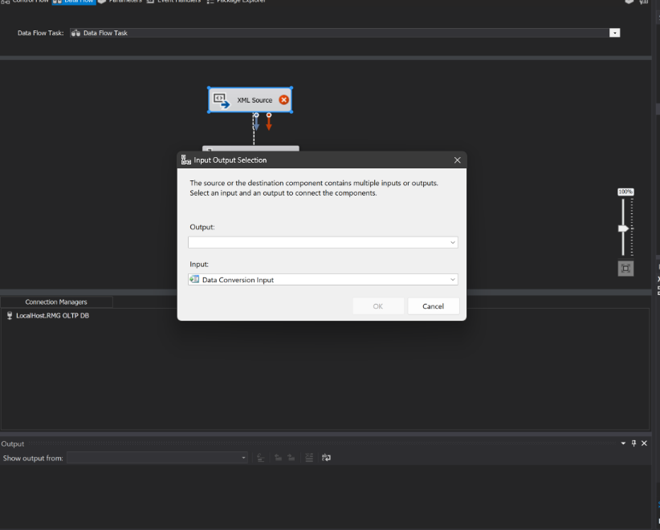

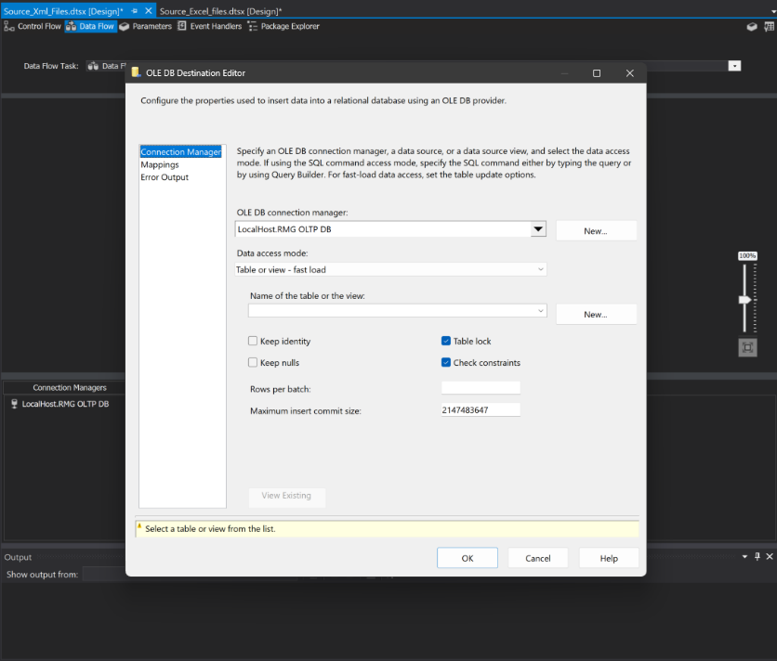

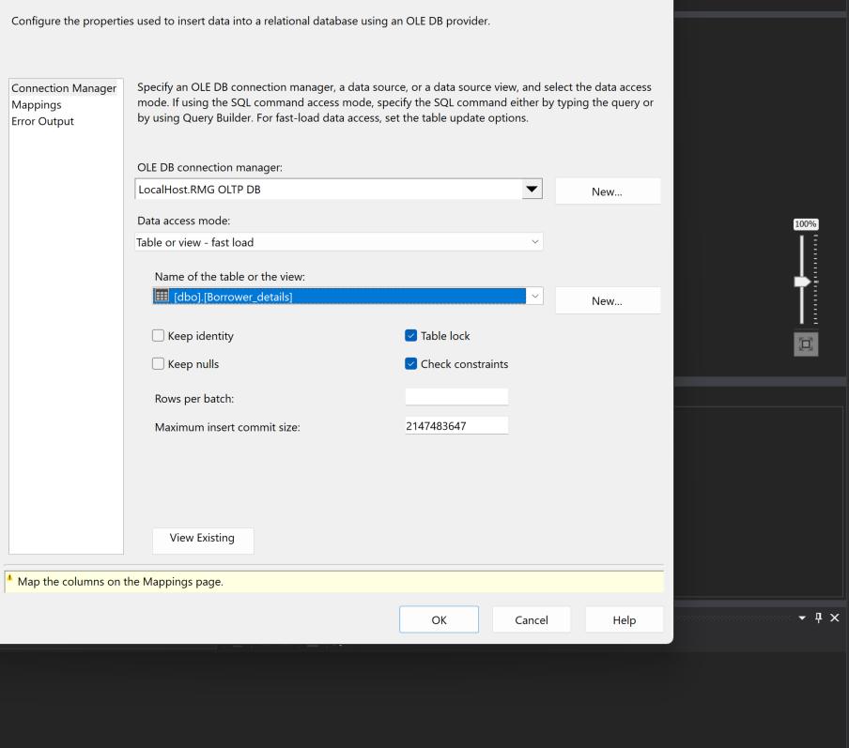

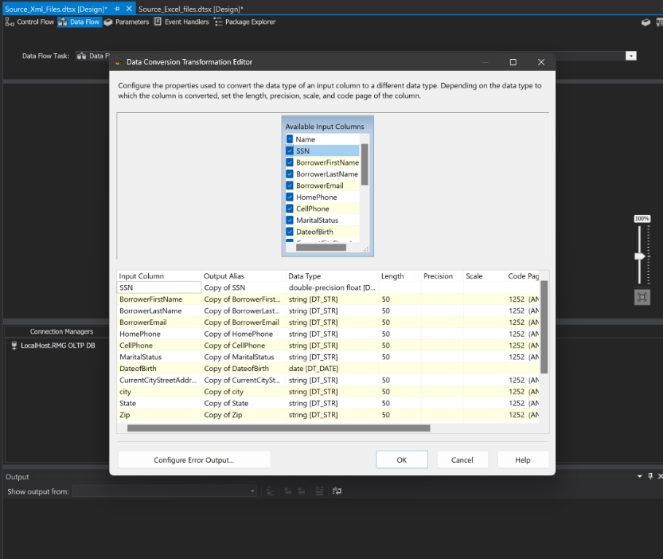

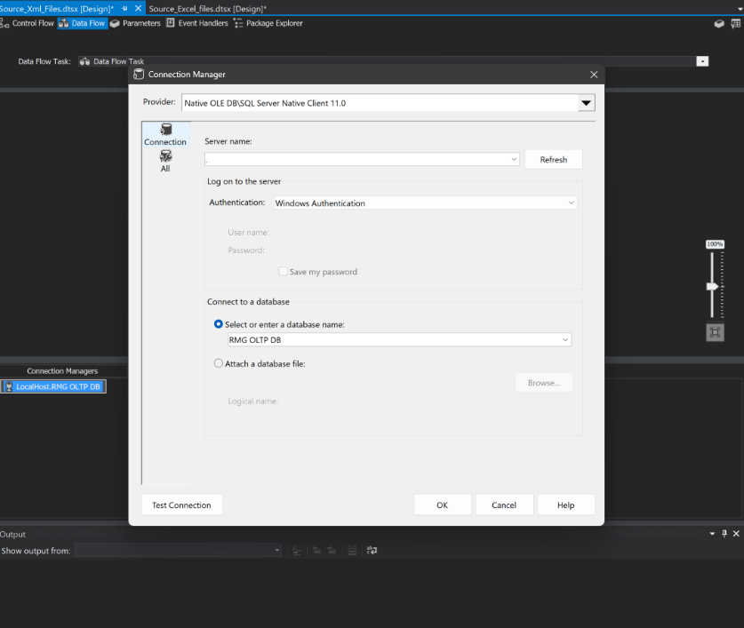

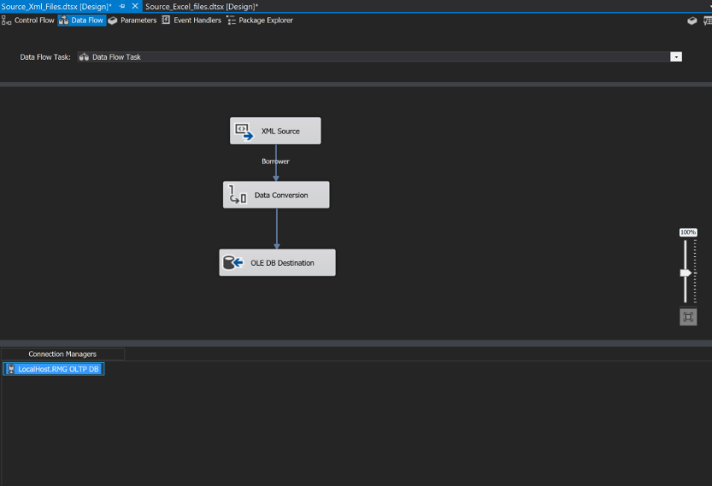

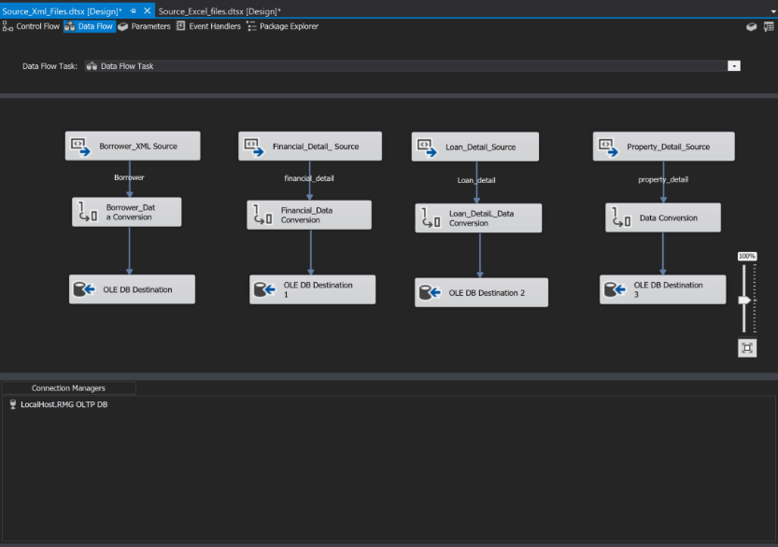

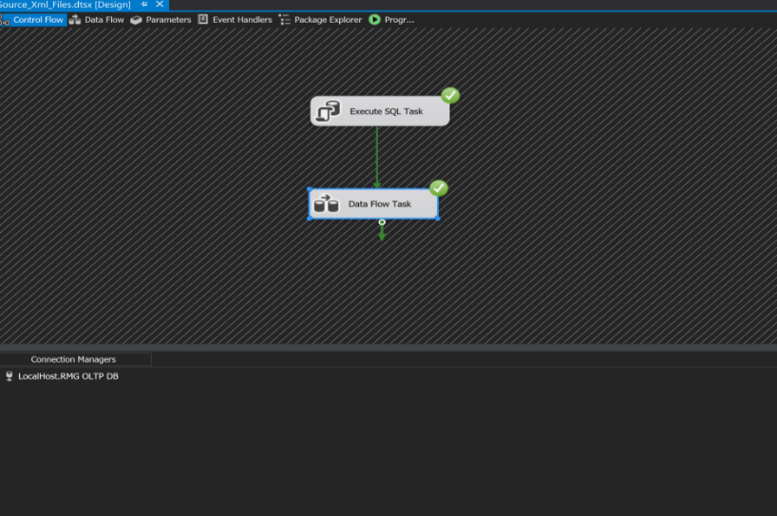

**Scenario 3 – OLTP Data:** Read OLTP data from SQL Server or Access database.

